Energy Test
Student: Class:
Score ____/ 14

Wavelength and frequency
1. The following diagram shows two vibrating tuning forks producing sound waves.
A | 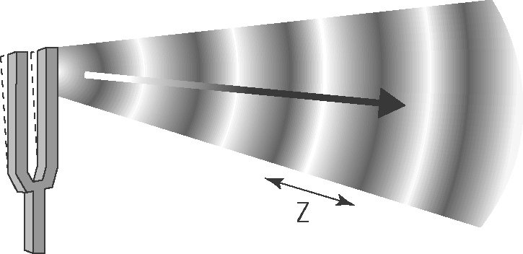 | (a) Identify the features of the wave labelled X, Y and Z.  X:  Y:  Z: (3)  (b) Which sound wave has the lowest pitch?  Explain.  (2)
B | 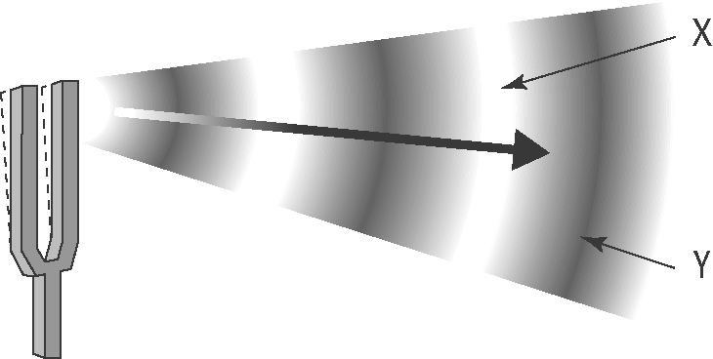
2. In the diagram below, identify the parts of a wave by using the provided definitions.
#____ = crest The highest point of the wave above the line of origin.
#____ = trough The lowest point of the wave below the line of origin.
#____ = line of origin Signifies the original position of the medium.
#____ = wavelength The distance between two consecutive crests.
#____ = amplitude The distance from the line of origin to a crest or trough of a wave. (5)
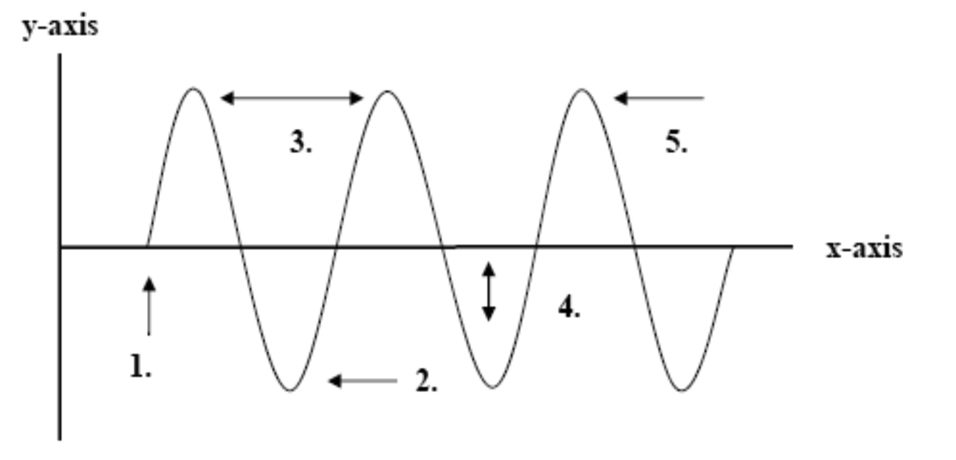

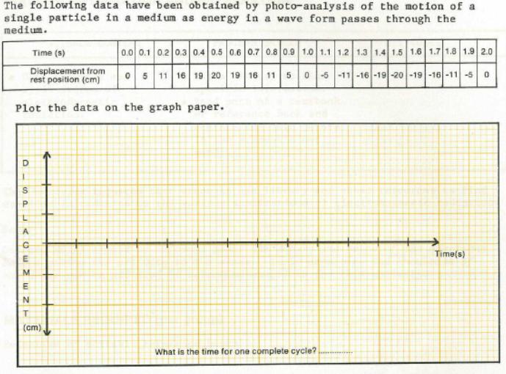(4)

